# CS 255 Business Requirements Document Template

Complete this template by replacing the bracketed text with the relevant information.

This template lays out all the different sections that you need to complete for Project One. Each section has guiding questions to prompt your thinking. These questions are meant to guide your initial responses to each area. You are encouraged to go beyond these questions using what you have learned in your readings. You will need to continually reference the interview transcript as you work to make sure that you are addressing your client’s needs. There is no required length for the final document. Instead, the goal is to complete each section based on your client’s needs.

**Tip:** You should respond in a bulleted list for each section. This will make your thoughts easier to reference when you move into the design phase for Project Two. One starter bullet has been provided for you in each section, but you will need to add more.

## System Components and Design

### Purpose

*What is the purpose of this project? Who is the client and what do they want their system to be able to do?*

* Our client DriverPass wants to build a system that allows people to take practice tests and schedule on the road training sessions. They want the data to be available to them both online and offline. They need both their internal staff and their customers online to be able to enter in their credentials and schedule or cancel appointments, enter in their pickup and drop off locations and see their progress in the program.

### System Background

*What does DriverPass want the system to do? What is the problem they want to fix? What are the different components needed for this system?*

* DriverPass sees a void in the market where people need help to pass their drivers test. To help with this they would like a system where people can take online practice tests and schedule time to have in person behind the wheel training. The system should allow users to log in using their own credentials that only allows them to access to the features and data that they have clearance for. The system should also track all of the users progress, reservations and cancelations.

### Objectives and Goals

*What should this system be able to do when it is completed? What measurable tasks need to be included in the system design to achieve this?*

* When completed this should be a functioning website that allows users to take practice tests and track their results. It should also allow customers to reserve, modify or cancel behind the wheel drivers training sessions. Users will also need to be able to track their progress by looking at their profile information.

## Requirements

### Nonfunctional Requirements

*In this section, you will detail the different nonfunctional requirements for the DriverPass system. You will need to think about the different things that the system needs to function properly.*

#### Performance Requirements

*What environments (web-based, application, etc.) does this system need to run in? How fast should the system run? How often should the system be updated?*

* The system will need to have both a web-based and a mobile application to allow user to access the application and complete the tasks that they will need to complete. There could be a desktop application for this to allow for more robust functionality that could take advantage of specific hardware features however this would require more setup and maintenance. The system will need to run fast enough so the user will be able to access their profiles and materials without having any unnecessary delays however since this application will not be relying heavily on moving large amounts of data it will not need the same speeds as an online gaming application.

#### Platform Constraints

*What platforms (Windows, Unix, etc.) should the system run on? Does the back end require any tools, such as a database, to support this application?*

* The system should run on both windows and mac due to the majority of potential users will be using these platforms, also the mobile app should run on both apple and android devices to ensure that any user that wishes to use the mobile app will be able to do so. As for back end tools there will need to be databases to store the users data, the behind the wheel schedule and information as well as all of the data for the users to study for their written tests. Another possible tool would be servers for both the web and mobile applications. These could be replaced by using AWS or another cloud based service.

#### Accuracy and Precision

*How will you distinguish between different users?* *Is the input case-sensitive? When should the system inform the admin of a problem?*

* To distinguish between different users each user will need both a username and password which will both need to be case sensitive. To add an extra layer of security two factor authentication could be used as well. For error reporting the application should detect and report errors or problems as they occur. The system then should be configured to notify the admin of any critical or high-priority issues that would require immediate attention, such as system crashes, security breaches or data loss.

#### Adaptability

*Can you make changes to the user (add/remove/modify) without changing code? How will the system adapt to platform updates? What type of access does the IT admin need?*

* It would be possible to make changes to the user without changing the underlying code using the tools and interfaces that would be available depending on the users credentials. A user would be able to create a new user account or make changes to their own account and an admin would be able to make changes to any account as long as they had the proper credentials to do so. The type of access that the IT admin would need would depend on what type of changes that admin would be required to complete. If they only needed access to modify user information and make changes to any information for the study guides or tests then their access would be limited to that and not let them make any changes to the code of the system. If they needed to make changes to the code for any reason, then they would need a higher level access. The level of access that any user should have should be limited to what they need to complete the tasks they have and nothing more.

#### Security

*What is required for the user to log in? How can you secure the connection or the data exchange between the client and the server? What should happen to the account if there is a “brute force” hacking attempt? What happens if the user forgets their password?*

* For a user to log in they would need their username, password and possibly a two factor authentication method. These will all be verified by the server to ensure that the user is authorized to access that account. To secure the data exchange between client and server, encryption technologies such as SSL/TLS or HTTPS should be used. These will encrypt the data transmitted between the client and server preventing eavesdropping and tampering. Each account should have a number of attempts that the user would be able to enter the incorrect password prior to the account being locked and an admin having to verify the users identity to unlock the account. By doing this it will prevent a “brute force” hacking attempt. If the user forgets their username or password there should be a link at the log in page that would allow then to enter their email address that is tied to the account so they could get an email sent to them that would let them start the process of resetting their password.

### Functional Requirements

*Using the information from the scenario, think about the different functions the system needs to provide. Each of your bullets should start with “The system shall . . .” For example, one functional requirement might be, “The system shall validate user credentials when logging in.”*

* The system shall be accessible online from anywhere.
* The system shall be able to track user activity including changes made to user records.
* The system shall allow customers to make reservations for driving lessons, including specifying the date, time, driver and car.
* The system shall allow customers to be able to register over the phone or online.
* The system shall be updateable so when the DMV makes any changes the system can be updated with the most current information.
* The system shall have a user-friendly interface.
* The system shall be secure including all users having a unique username and password and all users only having access to the roles that are required for them to have.

### User Interface

*What are the needs of the interface? Who are the different users for this interface? What will each user need to be able to do through the interface? How will the user interact with the interface (mobile, browser, etc.)?*

* The interface needs an easy to use log in section so users can easily find where to enter their username and password.
* The interface needs to display the users online test progress.
* The interface needs to display the user’s information.
* The interface needs to display the driver’s notes.
* The interface needs to display both the student and driver’s photo.
* The different users for the interface would be the students and the employees that will be entering in the information of the students that call in to schedule and the driving instructors that will be entering in the driving notes for the students. There also would need to be a separate interface for the admins that will need to do the maintenance on the application.
* The students will be interacting with the interface with either a browser or a mobile device. Employees will be interacting with the interface with a browser.

### Assumptions

*What things were not specifically addressed in your design above? What assumptions are you making in your design about the users or the technology they have?*

* The biggest assumption that is being made about the users and the technology they have is that they will either be using a PC or a mobile device to interact with the system. Also, the device that they are using will be up to date and capable of securely interacting with the system in at a speed that will not hinder the user’s experience.
* Another assumption would be that the user has an internet connection with both the speed and stability to let the user interact with the system without having constant problems.
* Another assumption would be that the user has the technical capability to be able to use this system without having someone supervise and teach them how to use it.

### Limitations

*Any system you build will naturally have limitations. What limitations do you see in your system design? What limitations do you have as far as resources, time, budget, or technology?*

* One limitation would be the ability of the system to handle a large number of simultaneous users. Due to this the system will need to be rapidly scalable to handle a larger number of users than originally planned.
* Each phase of the system’s construction was given a set amount of time that it will need to be completed within.
* Another limitation would be if the security of the system is designed to properly protect the users sensitive information and prevent unauthorized access.
* If the cost of implementing the system design goes over the allotted budget due to going over the time, needing to bring in extra people to cover knowledge gaps or the hosting costs being higher than expected could require trade-offs in features or quality to keep within budget.

### Gantt Chart

*Please include a screenshot of the GANTT chart that you created with Lucidchart. Be sure to check that it meets the plan described by the characters in the interview.*

*[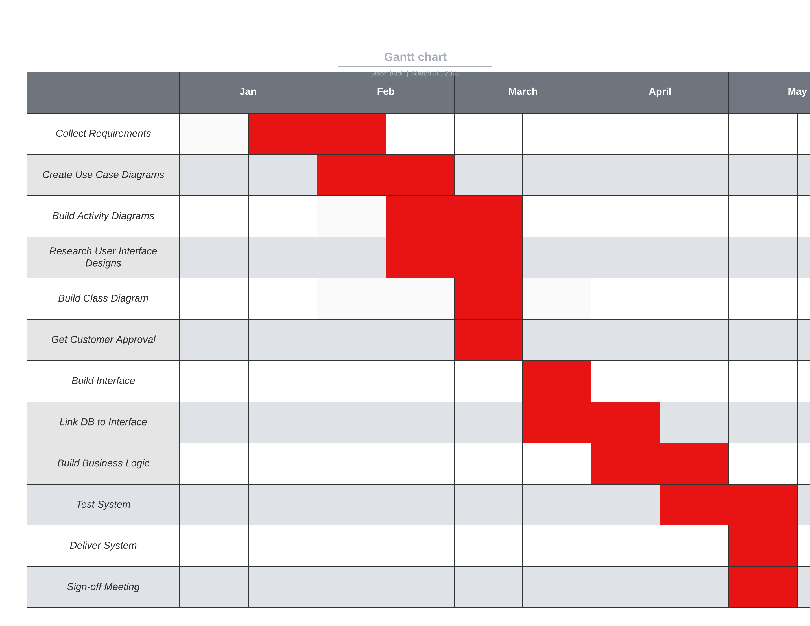](https://lucid.app/lucidchart/ea612bb1-34c4-40ec-9a7b-c99b758efa22/edit?crop=content&page=0&signature=9862165a80a26eacfa6d093941462aa8515261c94ef76d0519a063ea41798afd)*